APP F

MARVELDROID WALKTHROUGH

MarvelDroid is an Android-based Capture The Flag (CTF) application inspired by the Marvel Universe’s Infinity Stones, designed to challenge players’ mobile security and reverse-engineering skills. Built with Kotlin and Android SDK, the app features six distinct challenges, each tied to an Infinity Stone and a unique flag in the format InfinityCTF{}.

Here’s a list of vulnerabilities associated with each challenge: Power Stone: Hidden Key in strings.xml (Obfuscation Issue) Vulnerabilities:
- Static Analysis: Attackers can extract the key from strings.xml using tools like APKTool or jadx.
- Weak Obfuscation: Even if obfuscated, keys can often be reverse-engineered.
- Decompilation: Attackers can inspect res/values/strings.xml and find the hardcoded key.

Space Stone: Fake API Request (Network Log Leak) Vulnerabilities:
- Logcat Exposure: Flag is leaked in logs, which can be accessed using adb logcat.
- Network Traffic Inspection: Attackers can use Burp Suite or MITMProxy to intercept network logs.
- Lack of Secure Logging: Log.d() statements can expose sensitive data.

Reality Stone: Require Patching the APK Vulnerabilities:
- Code Modification: Attackers can use Smali Patching to modify the APK and bypass restrictions.
- Frida / Xposed: Dynamic instrumentation can alter runtime behavior.
- Signature Verification Bypass: If not properly implemented, attackers can resign a patched APK and run it.

Soul Stone: Authentication Bypass Vulnerabilities:
- Hardcoded Credentials: If the app stores login credentials locally, they can be extracted.
- Broken Authentication Logic: Weak or missing validation allows bypassing login screens.
- Token Tampering: If JWT or API tokens are predictable, they can be exploited.
  - Debug Mode Exploitation: If android:debuggable="true", attackers can use adb shell am start to bypass login.

Time Stone: Weak Crypto (Base64 Encoding) Vulnerabilities:
- Base64 is not encryption: It’s just encoding and can be easily decoded.
- Hardcoded Keys: If weak keys are used (e.g., AES with a static key), attackers can extract them.
- Reversible Encryption: Using weak ciphers (e.g., DES, RC4) makes it easy to brute-force or decrypt.

Mind Stone: Exported Activity Vulnerability Vulnerabilities:
- Unprotected Exported Activities: If an activity is exported (android:exported="true") and lacks authentication, attackers can start it using adb shell am start.

- Intent Manipulation: Attackers can pass custom intents with malicious data.
- Component Hijacking: If android:exported="true" is set without permission checks, any app can launch it.
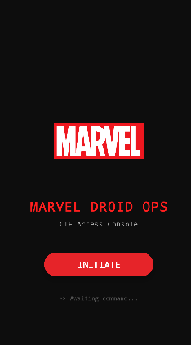

- Power Stone Challenge (10 Points)
Objective: Extract and decode a hidden key stored in strings.xml to get the flag.

  - Flag Format: InfinityCTF{power_<6-digit-timestamp>}
  - Points: 10

Tools Needed
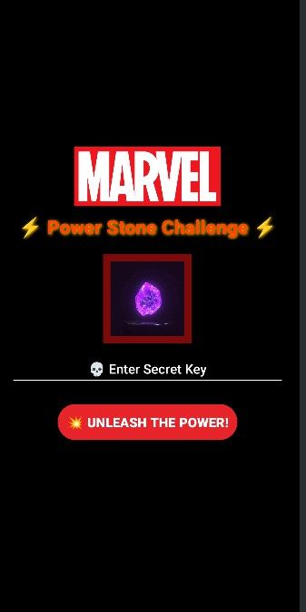
  - ADB
  - JADX

Find the <string> tag with name power_stone_secret. It contains a Base64-encoded, GZIP-compressed, and then Base64-encoded-again value.

- Space Stone Challenge (20 Points)

Objective: Capture a flag leaked via a fake API request in network logs.

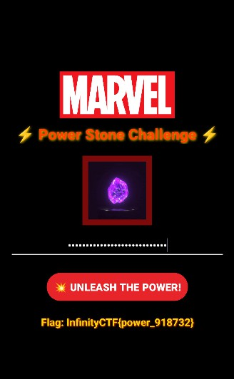
  - Flag Format: InfinityCTF{<8-char-UUID>}
  - Points: 20

Tools Needed

  - ADB (for logcat)


- Soul Stone Challenge (15 Points)

Objective: Bypass authentication by activating a backdoor (tap 5 times quickly).

  - Flag Format: InfinityCTF{soul_<6-digit-timestamp>}
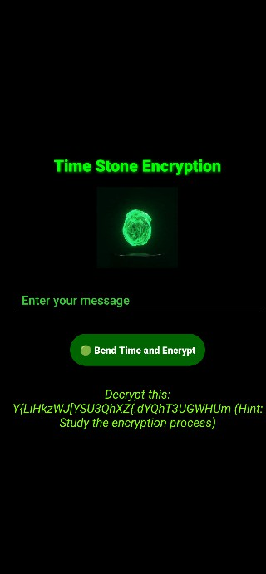
  - Points: 15 Tools Needed
  - Just the app on a device/emulator.

- Time Stone Activity

We get a string that’s asked to be decrypted. We also know that the flag is of the format Infinity CTF{}, so that gives the idea about how the string is structured as well.
We decompile the APK using JADX and look at the necessary kotlin file.

The score also get’s updated thoroughly as



- MindStoneActivity


Looking at the activity screen gives us the idea that this is related with launching intents.

The score also get’s updated accordingly as

- Reality Stone Challenge (15 Points)


This is what the UI is shown and it gives us the clue that we need to bend the app’s logic i.e. modify the code.

